Cloud Service Models (IaaS, PaaS, SaaS)

Tasks

1. List three popular apps you use (like Instagram, Zomato, or Spotify) and for each, identify whether it is most similar to IaaS, PaaS, or SaaS. Briefly explain your reasoning for each choice.

ANS:

App | Cloud Service Model | Reason
Instagram | SaaS (Software as a Service) | Users can access Instagram directly to share photos, videos, and messages without installing or managing its servers.
Google App Engine | PaaS (Platform as a Service) | Developers can build, deploy, and manage applications without managing the underlying servers.
Amazon EC2 | IaaS (Infrastructure as a Service) | Users can rent virtual servers and manage their operating systems, storage, and applications.

2. Create a table comparing IaaS, PaaS, and SaaS with at least three points for each model, using real-world examples such as AWS EC2, Google App Engine, and Office 365.

ANS:

Comparison Point | IaaS | PaaS | SaaS
Full Form | Infrastructure as a Service | Platform as a Service | Software as a Service
Purpose | Provides virtual servers, storage, and networking | Provides a platform to develop and deploy applications | Provides ready-to-use software over the internet
User Manages | OS, applications, and data | Applications and data | Mainly uses the software
Provider Manages | Physical servers and virtualization | Infrastructure, OS, and runtime | Infrastructure, platform, and software
Technical Knowledge | High | Medium | Low
Real-World Example | AWS EC2 | Google App Engine | Microsoft Office 365
Common Use | Hosting servers and websites | Building and deploying applications | Creating documents, emails, and presentations

Example: AWS EC2 = rent a server; Google App Engine = deploy an application; Office 365 = use Word, Excel, and Outlook online.

3.Sign up for a free AWS account (or use an existing one), navigate to the EC2 dashboard, and launch a new t2.micro EC2 instance running Ubuntu 22.04. Take a screenshot of your running instance in the AWS console. Use the 'Launch Instance' button and select the free tier eligible Ubuntu AMI.

ANS:

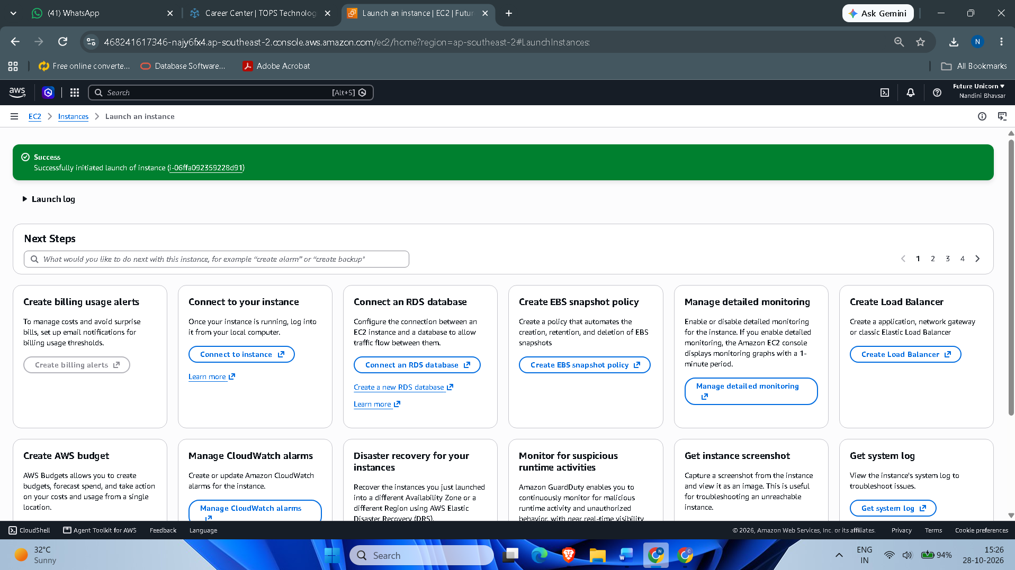

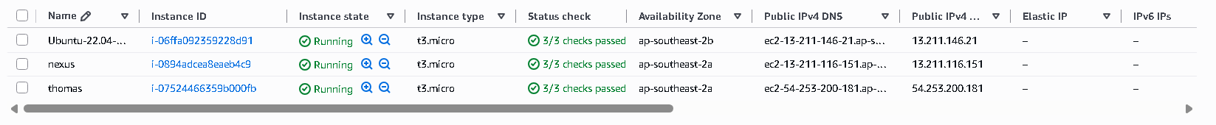

4. After your EC2 instance is running, connect to it using SSH from your local terminal or an online SSH client. Run the command 'uname -a' and note the output. You may need to use the .pem key file downloaded during instance setup.

ANS:

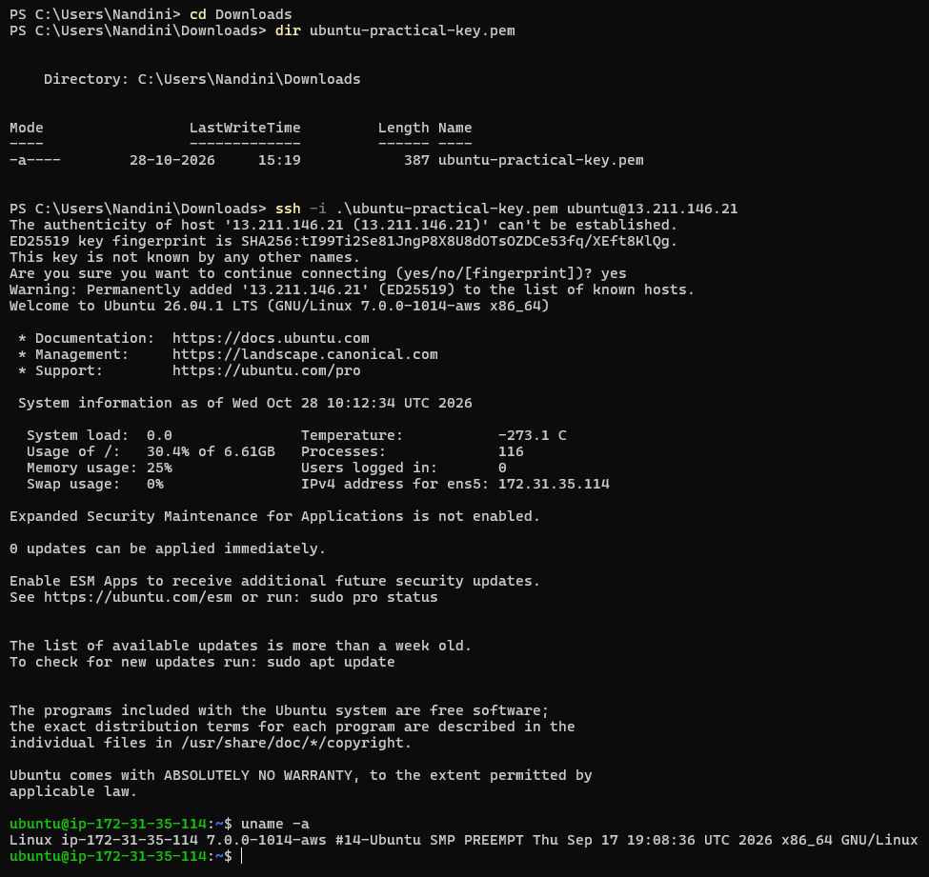

I connected to my AWS EC2 Ubuntu instance using SSH and executed the uname -a command to check system information.
The output displayed the Linux kernel version, hostname, and architecture (x86_64), confirming successful execution.

5. Suppose you want to host a simple static website for your college fest using your EC2 instance. List the basic steps you would follow after launching the instance to make your site accessible to everyone. Write 3-5 steps in order.

ANS:

- Connect to EC2: Connect to the instance using SSH and update the system packages.
- Install a web server: Install Apache using sudo apt install apache2 -y.
- Upload website files: Place the HTML, CSS, and JavaScript files in /var/www/html/.
- Configure security group: Allow inbound HTTP traffic on port 80 from everyone (0.0.0.0/0).
- Access the website: Copy the instance’s Public IPv4 address into a browser to view the college fest website.

